Gesture-Based Desktop Control System
A Real-Time Computer Vision Approach to Contactless Human-Computer Interaction
Author: Vandan Agrawal

Project Domain: Computer Vision, Human-Computer Interaction, Real-Time Systems
Platform: Microsoft Windows
Input Modality: Standard Laptop Webcam
Control Paradigm: On-Demand Gesture Recognition and Desktop Action Synthesis

Table of Contents
- Executive Summary
- Introduction and Motivation
- Problem Definition and Scope
- Literature Context and Theoretical Foundations
- System Architecture and Design Philosophy
- Perception Layer: Video Acquisition and Hand Landmark Detection
- Geometric Reasoning: Finger State Classification
- Thumb Extension Analysis: A Multi-Criteria Geometric Approach
- Pinch Distance Metric and Palm-Width Normalization
- High-Level Gesture Classification and Labeling
- System State Management and Activation Toggle
- Cursor Control: Coordinate Mapping, Exponential Smoothing, and Adaptive Responsiveness
- Click Interaction: Pinch Hysteresis, Aim Lock, and Debounce Mechanisms
- Brightness Control: Vertical Motion Delta Analysis
- Volume Control: Rotational Angle Computation and Wrapped Angular Accumulation
- Application Switching: Temporal Hold Entry, Horizontal Navigation, and Keyboard Synthesis
- Gesture Priority Arbitration and Conflict Resolution
- User Interface Overlay and Real-Time Diagnostic Feedback
- Configuration Philosophy and Parameter Sensitivity
- Development Methodology and Iterative Refinement
- Performance Characteristics and System Evaluation
- Limitations and Boundary Conditions
- Research Contributions and Academic Significance
- Future Directions
- Conclusion
- Appendix A: Landmark Anatomy Reference
- Appendix B: Complete Parameter Reference Table

1. Executive Summary
This report presents the complete design, theoretical underpinning, and implementation rationale of a Gesture-Based Desktop Control System that enables users to operate a Windows computer entirely through hand gestures captured by a standard webcam. The system supports six distinct interaction modalities: system activation and deactivation through a sustained closed-fist pose; cursor movement through index finger tracking with stabilized screen mapping; left mouse clicking through thumb-to-index pinch with hysteresis-based debouncing; display brightness adjustment through vertical two-finger sliding motion; system volume adjustment through rotational motion analysis of a three-finger cluster; and application switching through an open-palm hold followed by horizontal navigation and pinch-based selection.
The architecture follows a strict layered pipeline separating perception (camera capture and hand landmark inference), interpretation (geometric finger state analysis and gesture classification), policy (state management and priority arbitration), action (operating system control synthesis), and feedback (live diagnostic overlay). The system is intentionally on-demand, remaining dormant until the user explicitly activates it with a deliberate gesture, thereby avoiding the surveillance characteristics of passive monitoring systems.
Key technical contributions include adaptive exponential smoothing with edge-aware responsiveness for cursor stabilization, multi-criteria geometric thumb classification robust to mirror-flipped video feeds, wrapped angular delta accumulation for continuous rotational volume control, pinch hysteresis with pre-click aim locking to eliminate cursor drift during click execution, and a priority arbitration scheme that resolves conflicts between gestures sharing overlapping finger configurations.
The system achieves interactive frame rates of twenty to thirty frames per second on typical laptop hardware, with perceptual control latency maintained below one hundred milliseconds through careful elimination of automation delays and adaptive signal processing.

2. Introduction and Motivation
The conventional desktop interaction paradigm assumes continuous physical contact with dedicated input peripherals: a mouse providing two-dimensional pointing and discrete button events, and a keyboard providing character and modifier key input. While this model is extraordinarily effective for sustained productivity work, it imposes constraints that become limiting in specific contexts. Presentation environments require the speaker to remain distant from the computer. Sterile or industrial settings may prohibit physical contact with shared surfaces. Accessibility needs encompass users with motor limitations that make fine mouse manipulation difficult. Creative workflows sometimes benefit from spatial, gestural interaction that maps physical movement to system parameters more intuitively than button presses.
Vision-based hand tracking offers a compelling alternative input channel: the user's hand becomes both the pointing device and the command surface, requiring no additional hardware beyond the webcam already present in virtually every modern laptop. However, naive implementations that simply map raw hand coordinates to screen positions suffer from jitter caused by camera noise, false activations from incidental hand movements, ambiguous gesture boundaries when multiple controls share similar finger configurations, and poor perceptual latency when signal processing introduces smoothing delays.
This project addresses these challenges through principled engineering of a complete control pipeline, from raw pixel capture through stable, intentional desktop action, with particular emphasis on the signal processing, geometric reasoning, and temporal logic that transform noisy continuous hand tracking into reliable discrete and continuous computer control.
The choice of an on-demand activation model is philosophically significant. Unlike background monitoring systems (posture trackers, fatigue detectors, attention monitors), this system activates only when the user deliberately enables it through a specific gesture. This respects user agency, avoids the discomfort of persistent camera surveillance, and mirrors the mental model of picking up a physical tool when needed and setting it down when finished.
2.1 Personal View of Computer Vision, Course Learning, and Future Study Interests
My personal view of computer vision has changed significantly through this project. Before implementing this system, it was tempting to think of computer vision primarily as a recognition problem: detect the hand, detect the fingers, and map the result to commands. The project made clear that this view is incomplete. A useful computer vision application must connect perception to decision-making, timing, uncertainty management, human intention, and system feedback. In other words, a vision model alone does not create an interaction system; the engineering around the model determines whether the output is stable, understandable, and useful.
The project also reinforced that real-time computer vision differs from offline image analysis. In offline analysis, an algorithm can spend more time on a frame and optimize for recognition accuracy. In this project, each frame is part of a continuous human feedback loop. A technically correct detection that arrives too late, jitters from frame to frame, or triggers at the wrong moment feels wrong to the user. This is why latency, smoothing, debounce logic, and clear state transitions became just as important as the underlying hand landmark detector.
From the course perspective, this project applied several computer vision concepts in a practical setting: image acquisition, color-space conversion, feature representation, tracking over time, geometric reasoning from visual features, normalization for scale invariance, and temporal filtering. The MediaPipe landmark model provided the low-level perception primitive, but the project still required interpreting those landmarks using classical geometry and signal-processing ideas. Concepts such as Euclidean distance, angle measurement through dot products, coordinate normalization, exponential smoothing, thresholding, and motion accumulation were all necessary to transform raw landmark coordinates into meaningful interaction.
The most important lesson learned is that robust vision systems must be designed around uncertainty. The hand tracker occasionally misclassifies the thumb, drops a landmark, or jitters during fast motion. Rather than assuming perfect perception, the system uses thresholds, hysteresis, cooldowns, hold times, priority arbitration, and mode locks to absorb uncertainty. This directly connects to broader themes in computer vision: models are probabilistic and imperfect, so downstream applications must be resilient.
In the future, I would like to study more advanced temporal models for gesture recognition, including Kalman filtering, One Euro filtering, hidden Markov models, recurrent neural networks, and transformer-based sequence classifiers. I would also like to study formal HCI evaluation methods such as Fitts' Law pointing tasks, task completion time analysis, false activation measurement, and user comfort studies. Finally, I am interested in learning more about privacy-preserving computer vision systems, because webcam-based interfaces must be designed carefully to maintain user trust.

3. Problem Definition and Scope
3.1 Core Problem Statement
Design and implement a real-time system that reliably translates hand poses and motions, captured through a standard laptop webcam, into meaningful desktop control actions, while maintaining stability against noise, preventing cross-activation between similar gestures, and providing responsive feedback that makes the system feel predictable and intentional rather than erratic.
3.2 Functional Requirements
The system must support six control capabilities, each activated by a distinct hand configuration: global system toggle (closed fist held briefly); mouse cursor positioning (single extended index finger); left mouse click (thumb-to-index pinch closure); display brightness adjustment (two-finger vertical sliding); system volume adjustment (three-finger rotational motion); and application switching (open palm hold followed by horizontal navigation and pinch confirmation).
3.3 Non-Functional Requirements
The system must operate at interactive frame rates (minimum twenty frames per second) on standard laptop hardware without dedicated GPU acceleration. Perceptual latency between hand movement and system response must remain below approximately one hundred milliseconds for cursor tracking. False activation rate must be low enough that the system does not interfere with normal computer use when active. The architecture must be modular, allowing individual control modules to be modified or extended without requiring changes to unrelated components.
3.4 Explicit Exclusions
The project scope explicitly excludes multi-hand interaction, depth-camera hardware, machine learning model training (the system uses a pre-trained hand landmark model), mobile or embedded platforms, and cross-platform operating system support. These boundaries keep the project focused on interaction design quality rather than breadth of platform coverage.

4. Literature Context and Theoretical Foundations
4.1 Hand Landmark Estimation as a Perception Primitive
Modern hand tracking has converged on the approach of regressing a fixed topology of landmark points from monocular RGB images. Google's MediaPipe Hand Landmarker represents the state of this approach for real-time applications: a palm detection stage locates the hand bounding region, followed by a landmark regression network that outputs twenty-one points representing the wrist and four joints per finger (metacarpophalangeal, proximal interphalangeal, distal interphalangeal or interphalangeal for the thumb, and fingertip). These landmarks are expressed in normalized image coordinates where the horizontal axis spans zero to one across frame width, and the vertical axis spans zero to one from top to bottom.
This representation is deliberately resolution-independent but not hand-size-independent: a hand closer to the camera produces landmarks spread more widely in normalized space than the same hand held farther away. Consequently, robust gesture metrics must normalize distances relative to hand-intrinsic measurements, such as palm width, rather than relying on absolute normalized distances.
4.2 Geometric Heuristics for Finger State Classification
The biomechanics of finger extension and flexion create predictable spatial relationships between joint landmarks. When a finger is extended (straight), its tip lies farther from the palm and higher in the image (assuming an upright hand facing the camera) than when the finger is curled. The simplest robust heuristic compares vertical positions: if the fingertip landmark has a smaller vertical coordinate (higher in the image) than the proximal interphalangeal joint, the finger is classified as extended.
This heuristic works reliably for the four non-thumb fingers under the assumption that the hand is oriented approximately upright with the palm facing the camera. It degrades under extreme hand rotations but remains effective within the interaction envelope expected for desktop gesture control.
4.3 The Thumb Problem in Monocular Hand Tracking
The thumb occupies a fundamentally different kinematic axis than the other fingers. It extends laterally and can rotate around its carpometacarpal joint in ways that do not produce consistent vertical displacement relative to the palm. Simple vertical comparison rules that work for other fingers fail for the thumb, particularly when the video feed is horizontally mirrored (as is standard for natural interaction). Robust thumb extension detection therefore requires geometric analysis of joint angles, directional vectors relative to the palm, and lateral spread metrics, an approach this project implements through three conjunctive geometric criteria.
4.4 Exponential Moving Average for Signal Smoothing
Raw landmark positions from frame-to-frame exhibit high-frequency jitter due to camera noise, slight hand tremor, and inference variability. The exponential moving average (EMA) is a classical technique for smoothing such signals:
smoothed(t) = alpha × raw(t) + (1 - alpha) × smoothed(t-1)
The smoothing factor alpha controls the tradeoff between responsiveness (high alpha, following input closely but preserving noise) and stability (low alpha, smooth output but introducing lag). For cursor control, this tradeoff is critical: too much smoothing makes the cursor feel sluggish and unresponsive; too little makes it jittery and difficult to target small interface elements.
4.5 Hysteresis for Threshold-Based Event Detection
When a continuous signal must trigger a discrete event, such as a click when fingers pinch together, a single threshold creates oscillation problems: if the signal hovers near the threshold due to noise, rapid on-off-on-off triggering occurs. Hysteresis resolves this by using separate thresholds for activation (press) and deactivation (release), with the release threshold positioned to require definitive movement away from the activation point before re-arming. This creates a dead band that absorbs noise near the transition boundary.
4.6 Angular Wrapping and Continuous Rotation Measurement
Measuring rotational motion requires computing the angle of a reference vector across frames and accumulating the change. The mathematical challenge is that angles are cyclic: they wrap from pi to negative pi, or equivalently from 180 degrees to negative 180 degrees. Without proper wrapping, a small physical rotation crossing this boundary produces a spurious large delta of approximately 2pi. The standard solution normalizes angular differences to the principal interval (-pi, pi] by adding or subtracting 2pi as needed, ensuring that small physical rotations always produce small computed deltas regardless of absolute angle position.
4.7 Debouncing and Temporal Gating in Interactive Systems
Physical buttons naturally debounce through mechanical hysteresis, but gesture-based inputs require explicit temporal logic. Hold-to-activate patterns, requiring a gesture to persist for a minimum duration before triggering, prevent accidental activation from transient hand poses. Cooldown timers prevent repeated triggering when a user maintains an activating gesture beyond the initial trigger point. Together, these mechanisms convert inherently noisy, continuous gesture signals into clean, intentional discrete events.

5. System Architecture and Design Philosophy
5.1 Pipeline Architecture
The system implements a linear processing pipeline that transforms raw camera frames into desktop control actions through five distinct layers.
The perception layer handles video acquisition from the webcam, frame pre-processing (horizontal mirroring for natural interaction), and hand landmark inference through the MediaPipe Hand Landmarker model. Its output is a set of twenty-one normalized two-dimensional landmark coordinates for the detected hand, along with handedness classification.
The interpretation layer consumes landmarks and produces semantic information: per-finger extension states (boolean up/down classification for each of five fingers), a normalized pinch distance metric, and a categorical gesture label. This layer encapsulates all geometric reasoning about hand pose.
The policy layer maintains system state (active versus inactive), enforces activation gestures, and arbitrates between competing control modes when multiple gesture conditions are partially satisfied simultaneously.
The action layer contains four specialized controllers: mouse, brightness, volume, and application switcher. Each is responsible for translating validated gesture events into operating system commands through appropriate platform APIs.
The feedback layer renders real-time diagnostic information as text overlay on the camera preview frame, making system state, detected gestures, and active control modes visible to the user for calibration and demonstration purposes.
5.2 Separation of Concerns
Each layer and each controller operates through a defined interface with minimal coupling to other components. The gesture detector does not know about mouse control; the volume controller does not know about brightness; the state manager does not know about specific gesture meanings beyond the closed-fist toggle. This separation enables independent development, testing, and modification of each concern.
5.3 Centralized Configuration
All tuneable numeric parameters, including thresholds, timing constants, smoothing factors, and step sizes, reside in a single configuration module. This design acknowledges that gesture systems require extensive per-user and per-environment calibration, and makes the tuning surface explicit and accessible without searching through implementation logic.
5.4 On-Demand Activation Philosophy
The system remains dormant, ignoring all control gestures, until the user deliberately enables it through a sustained closed-fist hold. This same gesture deactivates it. The activation model means the camera can remain open for preview without the system inadvertently moving the cursor, clicking, or adjusting settings. This is both a usability decision and a philosophical one: the system is a tool the user picks up and puts down, not an ambient intelligence that acts on its own judgment.

6. Perception Layer: Video Acquisition and Hand Landmark Detection
6.1 Camera Interface and Frame Pre-Processing
The system opens a video capture session on the default camera device, requesting a frame resolution of 960 by 540 pixels. These dimensions balance spatial detail, sufficient for landmark precision, against computational cost, since smaller frames process faster. If the camera hardware does not support the requested resolution, it delivers its native dimensions instead.
Each captured frame undergoes horizontal mirroring before any further processing. This mirror transformation is essential for natural interaction: without it, moving the physical hand to the right would move the on-screen hand representation to the left (as in a non-reversed video feed), creating a cognitive disconnect that makes cursor control extremely difficult. The mirrored view matches the mental model of looking in a mirror, where left-right movements correspond intuitively.
6.2 Hand Landmark Inference
The mirrored frame is converted from BGR color space, OpenCV's native format, to RGB, MediaPipe's expected input format, and wrapped in a MediaPipe Image container. The Hand Landmarker model processes this image in video mode, which leverages temporal continuity between frames to improve tracking stability compared to treating each frame independently. The model requires monotonically increasing timestamps, provided by multiplying the system clock by one thousand to produce millisecond values.
The inference model outputs, for each detected hand, a list of twenty-one landmark points with normalized x, y coordinates and relative depth z, and a handedness classification (Left or Right) with confidence score. The system is configured to track at most one hand, simplifying downstream logic that would otherwise need to handle multi-hand disambiguation.
6.3 Detection and Tracking Confidence Thresholds
Two confidence thresholds gate the pipeline: a detection confidence of 0.7 determines how certain the model must be that a hand is present before reporting it, and a tracking confidence of 0.6 determines when the model should re-trigger full detection versus maintaining its temporal tracking estimate. Higher detection confidence reduces false hand detections from non-hand objects; the slightly lower tracking confidence allows tracking to persist through brief moments of reduced visibility without dropping out.
6.4 Model Distribution and Automatic Acquisition
The landmark model is distributed as a pre-trained task file. On first system launch, if this file is not present locally, it is automatically downloaded from Google's model hosting infrastructure. This ensures reproducible deployment across different machines while avoiding the need to include large binary files in the source repository.

7. Geometric Reasoning: Finger State Classification
7.1 The Vertical Comparison Heuristic for Non-Thumb Fingers
For each of the four non-thumb fingers (index, middle, ring, pinky), extension is determined by comparing the vertical position of the fingertip landmark against the proximal interphalangeal (PIP) joint landmark. In the normalized coordinate system where the image origin is at the upper-left corner, smaller vertical values correspond to positions higher in the frame. When a finger is extended, its tip projects higher in the image than its PIP joint. When curled, the tip drops below the PIP.
Formally, for a finger with tip landmark at position (x_tip, y_tip) and PIP landmark at position (x_pip, y_pip):
finger_extended = y_tip < y_pip
This heuristic is applied to the index finger (tip at landmark 8, PIP at landmark 6), middle finger (tip at landmark 12, PIP at landmark 10), ring finger (tip at landmark 16, PIP at landmark 14), and pinky finger (tip at landmark 20, PIP at landmark 18).
7.2 Assumptions and Validity Envelope
The vertical comparison assumes the hand is held approximately upright with the palm facing the camera. Under this assumption, finger extension consistently produces upward tip displacement. The heuristic degrades when the hand is rotated significantly, such as palm facing sideways or downward, but the interaction design inherently encourages upright palm-forward hand positions because this orientation also produces the most stable landmark tracking from the front-facing camera.
7.3 Binary State Representation
The output of finger state classification is a dictionary mapping each finger name, thumb, index, middle, ring, and pinky, to a boolean value. This binary representation, where each finger is either up or down, forms the foundation for gesture classification, which matches specific combinations of extended fingers to gesture labels.

8. Thumb Extension Analysis: A Multi-Criteria Geometric Approach
8.1 Why the Thumb Requires Special Treatment
The thumb's carpometacarpal joint allows rotation and opposition movements that the other fingers cannot perform. When the hand faces the camera, thumb extension occurs primarily along the horizontal axis rather than the vertical axis used for other fingers. Furthermore, horizontal mirroring of the video feed reverses the apparent direction of thumb extension, making handedness-dependent horizontal rules unreliable. A purely vertical comparison fails because the thumb tip may remain at approximately the same height as its base joints even when fully extended laterally.
8.2 Criterion A: Joint Straightness at the Interphalangeal Joint
When the thumb is extended, the angle at its interphalangeal (IP) joint approaches 180 degrees. When curled into the palm, this angle decreases significantly. The system measures this angle by constructing two vectors emanating from the IP joint: one toward the metacarpophalangeal (MCP) joint, and one toward the thumb tip.
The angle between these vectors is computed using the dot product formula:
cos(theta) = (v1 dot v2) / (|v1| × |v2|)
Where v1 is the vector from IP to MCP, v2 is the vector from IP to tip, and the dot product is computed in two-dimensional normalized image coordinates. The cosine value is clamped to the valid range [-1, 1] to handle floating-point imprecision before computing the arc-cosine. The resulting angle in degrees must exceed 150 degrees for this criterion to be satisfied, indicating a relatively straight thumb joint.
8.3 Criterion B: Direction Away from Palm Center
Even a straight thumb could point inward toward the palm if the hand is in an unusual configuration. This criterion verifies that the thumb tip points away from the palm's geometric center. The palm center is estimated as the average position of three stable landmarks: the wrist, the index MCP, and the pinky MCP.
Two vectors are constructed from the thumb MCP: one pointing toward the thumb tip (the thumb's direction), and one pointing toward the palm center (the inward direction). The normalized dot product between these vectors measures directional alignment:
dir_cos = (thumb_direction dot toward_palm) / (|thumb_direction| × |toward_palm|)
A value of +1 would mean the thumb points directly toward the palm center; a value of -1 means it points directly away. The criterion requires dir_cos < -0.10, meaning the thumb must point predominantly away from the palm center with a small tolerance band.
8.4 Criterion C: Lateral Spread from Index Finger Base
The final criterion requires physical separation between the thumb tip and the index finger's MCP joint, measured as Euclidean distance in normalized coordinates. This distance must exceed 55 percent of palm width, the distance between index MCP and pinky MCP. This criterion prevents false thumb-up classification when the thumb is relaxed against the side of the index finger, a common resting position during index-only pointing gestures.
8.5 Conjunctive Logic and Conservative Design
All three criteria must be simultaneously satisfied for the thumb to be classified as extended. This conservative AND-logic approach prioritizes avoiding false positives over maximizing detection sensitivity. The consequence is occasional false negatives during extreme hand rotations, which is acceptable because false thumb-up classifications would spuriously activate volume control or interfere with brightness gating.
8.6 Relaxed Thumb Detection for Volume Mode
During volume control, hand rotation can cause the strict thumb classifier to briefly report the thumb as retracted even though the user intends to maintain the three-finger volume gesture. To prevent volume mode from dropping out during rotation, the main control logic applies a relaxed alternative: if the pinch distance ratio exceeds a threshold, indicating thumb and index are not close together, and the distance from thumb tip to thumb MCP exceeds a fraction of palm width, indicating physical thumb extension, the thumb is considered sufficiently present for volume mode continuity. This relaxed rule applies only within the volume activation context and does not affect other gesture classifications.

9. Pinch Distance Metric and Palm-Width Normalization
9.1 Defining Pinch Strength
The proximity of thumb tip to index fingertip quantifies pinch gesture intensity. Raw Euclidean distance between these two landmarks in normalized image coordinates provides the measurement:
pinch_distance = sqrt((x_thumb_tip - x_index_tip)^2 + (y_thumb_tip - y_index_tip)^2)
However, this raw distance varies with hand distance from camera, because a hand held closer produces larger normalized distances between any two landmarks, and with individual hand proportions. Direct comparison against fixed pixel thresholds would require per-user calibration.
9.2 Palm-Width Normalization
To achieve scale invariance, pinch distance is divided by palm width, the Euclidean distance between the index finger MCP (landmark 5) and the pinky MCP (landmark 17):
palm_width = sqrt((x_index_mcp - x_pinky_mcp)^2 + (y_index_mcp - y_pinky_mcp)^2)
pinch_ratio = pinch_distance / palm_width
This ratio remains approximately constant regardless of hand distance from the camera, because both numerator and denominator scale proportionally with apparent hand size. A ratio near zero indicates fingers touching (full pinch); a ratio exceeding one indicates fingers spread wider than palm width (fully open). The system uses threshold values around 0.45 to 0.65 for various pinch-related decisions, which map to intuitive physical finger separations across different hand sizes.

9.3 Safety Against Degenerate Cases
If palm width falls below a tiny epsilon value, indicating tracking failure or extreme foreshortening, the ratio defaults to 1.0 (fully open), preventing false pinch detection from division instability.

10. High-Level Gesture Classification and Labeling
10.1 Set-Based Matching
Given the five boolean finger states, gesture classification constructs the set of currently extended fingers and matches it against a predefined catalog of meaningful combinations.
An empty set, meaning no fingers extended, maps to the closed fist label, indicating a system toggle candidate. The complete set of all five fingers maps to the open palm label, indicating an application switch candidate. The singleton set containing only the index finger maps to index point, the cursor control candidate. The set containing thumb and index maps to the click candidate pose. The set containing index and middle without thumb maps to the brightness candidate. The set containing thumb, index, and middle maps to the volume candidate.
Any combination not matching these patterns receives a generic label indicating an unrecognized configuration.
10.2 Labels as Advisory Information
These gesture labels serve primarily as diagnostic overlay text for the user. Actual control activation applies additional context-dependent conditions beyond simple finger set matching: the system must be active, priority rules must not block the action, temporal conditions must be met (hold durations, cooldowns), and specific exclusion conditions must not apply. The label system provides transparency about what the geometric classification engine sees, while the policy layer determines what the system actually does.

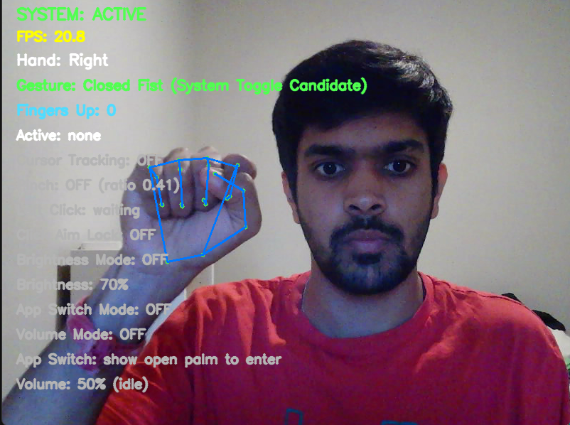
11. System State Management and Activation Toggle
Figure 1: Closed-fist gesture for program activation/deactivation.
11.1 Binary State Model
The system maintains a single primary boolean state: active or inactive. When inactive, all control gestures (cursor, click, brightness, volume, app switch) are ignored. Only the activation gesture (closed fist hold) is monitored. When active, all control gestures become available, and the same closed fist gesture deactivates the system.
11.2 Hold-to-Toggle Mechanism
Accidental system toggling from brief hand closures, such as grasping an object or transitioning between gestures, would severely degrade usability. The system therefore requires the closed fist to persist for a minimum number of consecutive frames (twelve frames, approximately four-tenths of a second at thirty frames per second) before toggling occurs.
Implementation uses a frame streak counter: each frame where all fingers are classified as down increments the counter; any frame where at least one finger is detected as up resets it to zero. When the counter reaches the hold threshold and sufficient time has elapsed since the last toggle (cooldown period of one second), the system state flips and the counter resets.
11.3 Cooldown Prevention of Rapid Toggling
Even after the hold threshold is met, the one-second cooldown prevents immediate re-toggling. Without this, a user maintaining a fist for slightly longer than the threshold would experience the system toggling on and then immediately off, or vice versa, as the streak counter re-accumulates. The cooldown ensures the user has time to open their hand and establish a different gesture before the toggle mechanism re-arms.
11.4 State Transition Side Effects
When the system transitions from active to inactive, any in-progress control modes are explicitly terminated. Most critically, if the application switcher is active, holding the Alt modifier key, the transition forces app switcher exit, releasing the Alt key to prevent a stuck modifier state that would interfere with subsequent keyboard interaction.

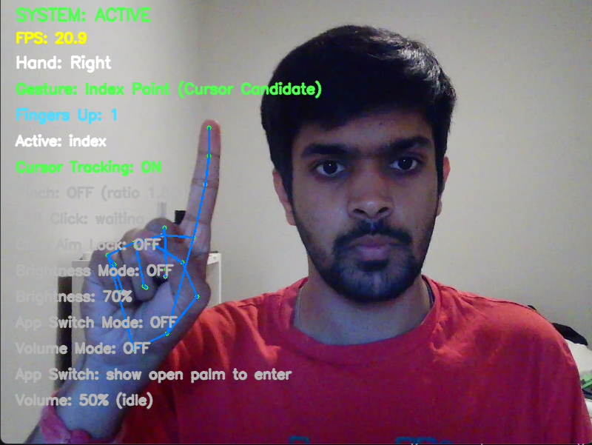
12. Cursor Control: Coordinate Mapping, Exponential Smoothing, and Adaptive Responsiveness

Figure 2: One-finger cursor control gesture using only the index finger.
12.1 The Mapping Problem
The index fingertip position in normalized camera coordinates, ranging from zero to one in both axes, must be transformed into absolute screen pixel coordinates, potentially spanning thousands of pixels. A direct linear mapping works in principle but creates an ergonomic problem: reaching the extreme edges and corners of the screen would require the user to position their finger at the extreme edges of the camera's field of view, which is physically uncomfortable and produces unstable tracking.
12.2 Margin-Based Mapping with Edge Compression
The system defines an active interaction region within the camera frame by applying configurable margins: 8 percent on each horizontal side and 12 percent on each vertical side. The finger position within this reduced region is linearly mapped to the full screen extent:
mapped_x = (x_finger - margin_x) / (1.0 - 2 × margin_x)
mapped_y = (y_finger - margin_y) / (1.0 - 2 × margin_y)
Both mapped values are clamped to [0, 1] before conversion to pixel coordinates. This means the user can reach all screen edges by moving their finger to the margin boundaries rather than the absolute frame boundaries, reducing physical strain while maintaining full screen coverage.
The final screen coordinates are:
screen_x = mapped_x × (screen_width - 1)
screen_y = mapped_y × (screen_height - 1)
12.3 Exponential Moving Average Smoothing
Raw mapped positions exhibit frame-to-frame jitter that would make precise targeting impossible. The system applies exponential moving average (EMA) filtering:
smoothed_x(t) = alpha × target_x(t) + (1 - alpha) × smoothed_x(t-1)
smoothed_y(t) = alpha × target_y(t) + (1 - alpha) × smoothed_y(t-1)
With the base smoothing factor alpha set to 0.35, the cursor incorporates 35 percent of the new position and retains 65 percent of its previous smoothed position each frame. This produces visibly smoother motion at the cost of introducing a small tracking delay: the cursor follows the finger with a slight lag proportional to (1 - alpha).
12.4 Adaptive Alpha: Context-Sensitive Responsiveness
A fixed smoothing factor creates problems in specific situations. Near screen edges, heavy smoothing prevents the cursor from reaching the boundary quickly, creating frustrating stickiness. During fast intentional movements, lag becomes perceptually unacceptable. The system addresses these through adaptive alpha selection.
When the mapped finger position lies within 4 percent of any screen edge, normalized distance from 0 or 1, alpha increases to 0.95, nearly instantaneous tracking that ensures edge reachability.
When the pixel distance between the new target and the current smoothed position exceeds 35 pixels, indicating deliberate fast movement, alpha increases to a minimum of 0.75, producing snappy response that follows large gestures without excess lag.
In all other cases, meaning normal mid-screen, moderate-speed movement, the base alpha of 0.35 applies, prioritizing stability for fine positioning tasks like targeting small interface elements.
12.5 Cursor Activation Conditions
Cursor tracking engages only under strict conditions: the system must be active; the index finger must be the only extended finger, with thumb, middle, ring, and pinky all down; the thumb must be sufficiently far from the index tip, with pinch ratio exceeding the arm threshold plus a small margin; and neither click aim lock, brightness mode, nor volume mode may be active. These guards prevent cursor movement during transitions between gestures and during the approach phase of a click, where any movement would displace the cursor from the intended click target.

12.6 State Reset on Tracking Loss
When cursor tracking becomes inactive, whether because the hand is lost, the gesture changes, or the mode switches, the smoothing state is explicitly cleared. This prevents a stale smoothed position from causing an abrupt jump when tracking resumes at a different hand location. The next tracking frame initializes fresh rather than blending from an outdated position.

13. Click Interaction: Pinch Hysteresis, Aim Lock, and Debounce Mechanisms
13.1 The Click Problem in Gesture Interfaces
Executing a mouse click through finger pinch creates a fundamental conflict with cursor positioning: the physical act of bringing thumb and index together inevitably displaces the index fingertip from its pre-pinch position, potentially moving the cursor away from the intended click target. Additionally, noisy pinch ratio measurements can oscillate near the activation threshold, potentially generating spurious clicks. The system addresses these through three coordinated mechanisms.
13.2 Click-Ready Hand Shape Validation
A click can only be triggered when the hand presents a specific configuration: index finger extended, and middle, ring, and pinky fingers all retracted. This prevents accidental clicks during brightness gestures, volume gestures, or transition poses. The thumb's state is deliberately not required for click readiness because the thumb must approach the index to execute the pinch.
13.3 Pre-Click Aim Lock
Before the pinch threshold is reached, the system detects the approaching pinch and freezes cursor movement. Two complementary mechanisms trigger the aim lock.
The arm lock engages when the click-ready hand shape is present and the pinch ratio drops below the arm threshold (0.52), indicating the thumb has begun approaching the index but has not yet completed the pinch.
The pre-lock engages even earlier, with pinch ratio below 0.65, when the index-only pose is active, catching the very beginning of the pinch approach trajectory.
While aim lock is active, cursor tracking is suppressed. The cursor remains frozen at its last position, so the inevitable fingertip displacement during pinch execution does not affect click targeting accuracy.
13.4 Hysteresis-Based Click Detection
The actual click event uses dual thresholds with latching. A click fires when the pinch ratio drops below the press threshold (0.45) and the click is not already latched. Upon firing, the latch engages, preventing additional clicks until the fingers separate.
The latch releases only when the pinch ratio rises above the release threshold (0.50), requiring definitive finger separation before re-arming. The gap between press (0.45) and release (0.50) creates a hysteresis band that absorbs noise when the pinch ratio hovers near threshold.
13.5 Temporal Cooldown
Even after latch release, a minimum interval of 0.35 seconds must elapse between successive clicks. This prevents double-clicks from rapid intentional pinch cycles and protects against residual oscillation in the release-rearm transition.
13.6 Click Execution
When all conditions align, meaning click ready, not latched, below press threshold, and cooldown elapsed, the system synthesizes a single left mouse button click through the operating system automation interface. The click occurs at the cursor's current position, frozen by aim lock, and the latch is set to prevent repetition.

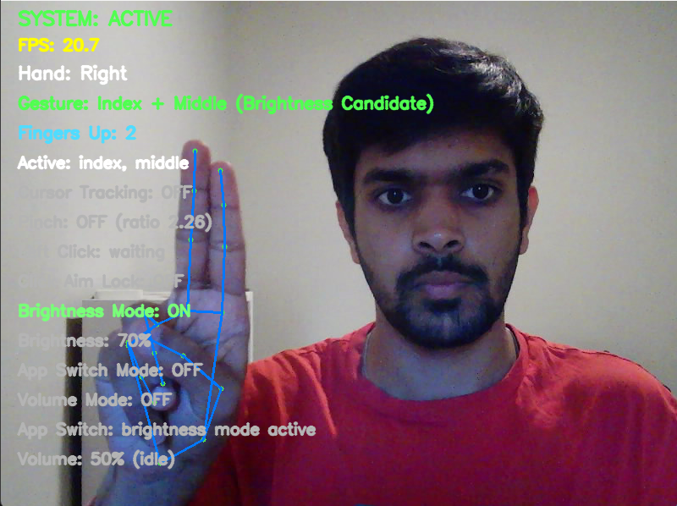
14. Brightness Control: Vertical Motion Delta Analysis

Figure 3: Two-finger brightness control gesture using index and middle fingers.
14.1 Gesture Configuration
Brightness control activates when the index and middle fingers are both extended while the thumb, ring, and pinky fingers are retracted. This two-finger raised pose, resembling a peace sign without the thumb, provides a natural vertical slider metaphor: moving the raised fingers upward increases brightness, moving them downward decreases it.
14.2 Vertical Motion Computation
The system tracks the vertical position, the y coordinate in normalized image space, of the middle fingertip across frames. On the first frame of brightness mode activation, the current position establishes a baseline without triggering any change. On subsequent frames, the system computes the vertical delta:
delta = y_previous - y_current
Because the image coordinate system places the origin at the top-left, y increases downward. Subtracting current from previous yields a positive delta when the hand moves upward, and a negative delta when the hand moves downward. This maps the intuitive up means more metaphor correctly to brightness increase.
14.3 Motion Threshold and Step Quantization
Small deltas below the motion threshold, 0.025 in normalized units, are ignored as noise. These small changes usually come from hand tremor or camera jitter insufficient to represent intentional motion. When the delta exceeds the threshold, the system computes the number of discrete brightness steps to apply:
steps = max(1, floor(|delta| / motion_threshold))
Each step changes brightness by a fixed percentage, 4 percent by default. The direction, increase or decrease, follows the sign of the delta. Larger hand movements thus produce proportionally larger brightness changes, providing analog-like responsiveness within a quantized control scheme.
14.4 Rate Limiting
A cooldown timer, 0.08 seconds between updates, prevents excessive system calls to the brightness hardware interface, which on some systems has significant latency or rate limitations. This produces approximately twelve brightness updates per second maximum during sustained motion, sufficient for smooth perceived adjustment without overwhelming the display driver.
14.5 Brightness Hardware Interface
The system reads current brightness as a percentage from 0 to 100 and writes target brightness clamped to this range. The underlying library abstracts Windows display brightness mechanisms, though not all display hardware supports programmatic brightness control equally.

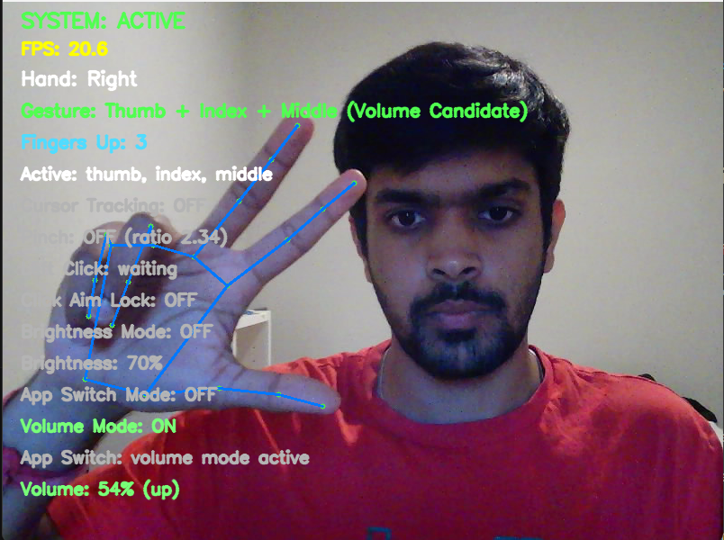
15. Volume Control: Rotational Angle Computation and Wrapped Angular Accumulation

Figure 4: Three-finger volume control gesture using thumb, index, and middle fingers.
15.1 Gesture Configuration and Rotational Metaphor
Volume control uses a three-finger pose: thumb, index, and middle extended; ring and pinky retracted. It interprets rotational motion of these fingertips around the palm center. The metaphor resembles turning a physical dial: clockwise rotation increases volume, and counterclockwise rotation decreases it. This provides continuous analog control through a natural physical motion that is distinct from the vertical sliding used for brightness.
15.2 Defining the Rotation Angle
The system constructs a geometric reference frame from hand landmarks. A fingertip cluster center is computed as the centroid of three points: the thumb tip, index tip, and middle tip positions. A palm anchor is computed as the centroid of three stable base landmarks: the wrist, index MCP, and pinky MCP. These points move minimally during finger rotation, providing a stable reference.
The angle of the vector from anchor to cluster center, measured in standard Cartesian convention, defines the instantaneous rotation angle. The y-axis is inverted to convert from image coordinates to mathematical coordinates:
dx = center_x - anchor_x
dy = -(center_y - anchor_y)
angle = atan2(dy, dx)
The y-inversion is necessary because image coordinates increase downward while the mathematical atan2 function assumes y increases upward. Without this correction, clockwise physical rotation would produce counterclockwise angular change.
15.3 Angular Delta and Wrapping
Between consecutive frames, the system computes the change in angle:
raw_delta = angle_current - angle_previous
This raw delta must be wrapped to the principal interval (-pi, pi] to handle the branch cut discontinuity. The wrapping procedure repeatedly subtracts 2pi if the delta exceeds pi, or adds 2pi if it falls below negative pi, until the result lies within the valid range. This ensures that a small physical rotation crossing the plus-or-minus pi boundary produces a small computed delta rather than a spurious jump of approximately 2pi.
15.4 Accumulation and Step Triggering
Wrapped angular deltas accumulate across frames into a buffer. When the absolute accumulated rotation exceeds the rotation step threshold, 0.32 radians or approximately 18 degrees, the system determines:
steps = max(1, floor(|accumulated_rotation| / rotation_step_threshold))
The direction is determined by the sign of the accumulated rotation: negative accumulation indicates clockwise motion due to coordinate conventions, which maps to volume increase when the clockwise-increases configuration flag is set.
Each step adjusts the system volume by the step scalar, 0.04 or 4 percentage points. After triggering, the accumulation buffer resets to zero, and a cooldown of 0.10 seconds prevents immediate re-triggering.
15.5 Volume Hardware Interface
The primary control path accesses the Windows audio endpoint through the COM-based pycaw library, reading and writing master volume as a scalar value in the range [0.0, 1.0]. The target scalar after adjustment is clamped to this range before writing. If the COM interface is unavailable due to driver or permission issues, a fallback path simulates keyboard volume up/down key presses through the automation library.

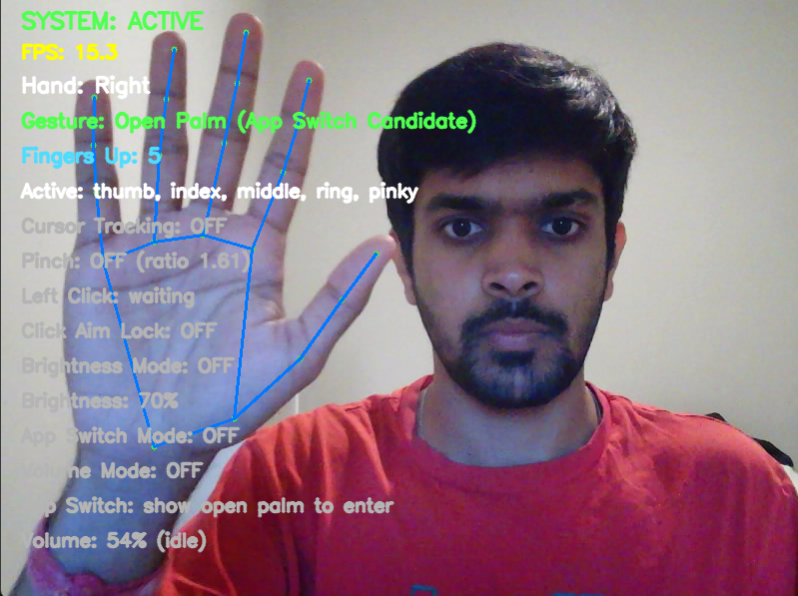
16. Application Switching: Temporal Hold Entry, Horizontal Navigation, and Keyboard Synthesis

Figure 5: Open-palm gesture used to enter Alt+Tab application switching mode.
16.1 Design Rationale
Application switching maps the Windows Alt+Tab task switcher interface to gesture control. The design uses a three-phase interaction: deliberate entry through a sustained open palm pose, navigation through horizontal hand motion, and confirmation through a pinch gesture. This mirrors the keyboard workflow of pressing and holding Alt, pressing Tab repeatedly to navigate, and releasing Alt to select, translated into spatial and gestural equivalents.
16.2 Entry Condition: Sustained Open Palm
All five fingers must be classified as extended simultaneously for the open palm to be detected. The system then requires this pose to persist continuously for one second before entering app switch mode. If the palm breaks, meaning any finger drops, before the hold duration completes, the timer resets. This one-second intentional hold prevents accidental mode entry from momentary hand openings during gesture transitions.
An additional entry cooldown, one second after the last mode exit, prevents rapid re-entry when the user has just selected an application and their hand may still be in a partially open configuration.
16.3 Mode Entry Actions
Upon entering app switch mode, the system synthesizes a key-down event for the Alt modifier key, holding it pressed, followed by a single Tab key press. This opens the Windows task switcher overlay showing thumbnails of running applications. The Alt key remains held throughout the mode, which keeps the Windows switcher visible.
16.4 Horizontal Navigation
Once in mode, the horizontal position of the index fingertip is tracked. A baseline is established on the first frame. Subsequent frames compute horizontal displacement from the baseline:
delta_x = current_x - previous_x
If the absolute displacement exceeds the movement threshold, 0.06 in normalized units, and the cycle cooldown has elapsed, 0.14 seconds between cycles, navigation occurs. Positive delta (rightward movement) sends Tab key presses to cycle forward through applications. Negative delta (leftward movement) sends Shift+Tab to cycle backward. The number of cycle steps is proportional to displacement magnitude, clamped between one and three steps per event. The baseline updates after each navigation event.
16.5 Selection and Timeout
When the user identifies the desired application in the switcher, a pinch gesture, raw pinch active and not requiring a specific finger configuration since the hand may be in various poses during switching, confirms selection. Upon pinch detection, with single-event latching to prevent repeated selections, the system releases the Alt key, which causes Windows to switch to the highlighted application. The mode then exits.
If six seconds elapse without any navigation activity or selection, the mode times out and exits automatically, releasing the Alt key. This safety mechanism prevents indefinite stuck states if the user loses hand tracking or forgets to confirm.
16.6 Isolation from Other Controls
While app switch mode is active, it consumes the entire frame's control budget. Cursor tracking, clicking, brightness, and volume are all explicitly suppressed. All other controllers' internal states are reset to prevent stale data from affecting behavior when mode exits. This total isolation prevents accidental cursor movement or clicks during application switching.

17. Gesture Priority Arbitration and Conflict Resolution
17.1 The Overlap Problem
Multiple gestures share partial finger configurations. Index-plus-middle (brightness) is a subset of thumb-plus-index-plus-middle (volume). Index-only (cursor) is a subset of index-plus-middle when the middle finger briefly flickers. The thumb's presence or absence gates the distinction between brightness and volume, but thumb classification has inherent noise. Without explicit priority rules, the system would oscillate between modes or activate unintended controls.

17.2 Priority Hierarchy
The main loop evaluates gesture conditions in a fixed priority order, where higher-priority matches consume the frame and prevent lower-priority actions:
- Priority 1: System toggle (closed fist), always evaluated regardless of other states.
- Priority 2: App switch mode, consuming the entire frame when active; entry evaluation when not active.
- Priority 3: Volume control, using thumb + index + middle with relaxed thumb and excluding brightness.
- Priority 4: Brightness control, using index + middle without thumb and excluding cursor and click.
- Priority 5: Click detection, using index with pinch approach and excluding cursor.
- Priority 6: Cursor tracking, using index only and treated as the lowest-priority control.
17.3 Mutual Exclusion Enforcement
When volume mode is active, the main loop explicitly resets the mouse controller, brightness controller, and click logic. When brightness mode is active, cursor tracking and click aim lock are suppressed. When app switch mode is active, all other controllers are reset and the loop continues early without evaluating cursor, click, brightness, or volume paths.
This explicit suppression in the main orchestration loop, rather than relying on individual controllers to self-inhibit, ensures that priority rules cannot be circumvented by unexpected state combinations within lower-level modules.

17.4 The Thumb Disambiguation Challenge
The most subtle conflict exists between brightness (index + middle, thumb down) and volume (thumb + index + middle, thumb up). When the user rotates their hand during volume control, the strict thumb classifier may momentarily report the thumb as retracted, causing a spurious switch to brightness mode. The relaxed thumb readiness check, using pinch spread and extension distance rather than strict geometric classification, provides hysteresis on the volume-to-brightness transition, preventing mode flickering during rotation.

18. User Interface Overlay and Real-Time Diagnostic Feedback
18.1 Purpose and Design Philosophy
The overlay renders system state directly onto the camera preview frame using text labels with color coding. This serves multiple purposes: providing the user with immediate feedback about what the system perceives (enabling self-correction of hand pose), supporting developer debugging during threshold tuning, and creating a visually informative demonstration for academic presentation.
18.2 Information Displayed
The overlay presents the following information in a vertical stack: system state (ACTIVE in green or OFF in red); frames per second as a numeric value; detected hand's handedness (Left, Right, or no hand warning); the classified gesture label; count of extended fingers; names of extended fingers; cursor tracking status; pinch status with live ratio value; click triggered indicator; click aim lock status; brightness mode status with current level percentage; app switch mode status with descriptive message; and volume mode status with current level percentage and direction.

18.3 Color Coding Convention
Active states display in green tones to indicate engagement. Triggered events, such as clicks and brightness or volume updates, flash in brighter highlight colors. Inactive states display in subdued gray. Error states, such as no hand detected, display in red. This allows rapid visual parsing of system state at a glance during interaction.

19. Configuration Philosophy and Parameter Sensitivity
19.1 Centralized Single-Source Tuning
All numeric parameters that influence system behavior reside in a single configuration module. This design acknowledges a fundamental reality of gesture-based interaction: threshold values that work well for one user, camera, lighting condition, and hand size may not work for another. By consolidating all tunable parameters in one location with descriptive names, the system makes calibration accessible without requiring understanding of the full implementation.
19.2 Parameter Categories and Sensitivity Analysis
Camera and model parameters, including resolution and confidence thresholds, affect the quality and reliability of raw landmark data. Higher confidence thresholds reduce false detections but may cause tracking dropouts under suboptimal lighting.
Timing parameters, including hold frames and cooldowns, affect the balance between responsiveness and accident prevention. Shorter hold durations make mode entry faster but increase accidental activation risk. Longer cooldowns prevent repeated actions but introduce perceptible delay between intentional repeated triggers.
Distance ratio parameters, including pinch thresholds, arm/release ratios, and pre-lock distance, affect click interaction. Lower press thresholds require deeper pinch for activation, making the gesture more intentional but harder to execute. Wider hysteresis bands provide more noise immunity but require more exaggerated finger opening between clicks.
Motion parameters, including brightness threshold and volume rotation step, affect continuous control sensitivity. Smaller thresholds make controls more responsive to subtle movements but more susceptible to triggering from involuntary hand tremor.
Smoothing parameters, including alpha, edge threshold, and fast-move threshold, affect cursor behavior. Each user's preference between stability and responsiveness differs, making these among the most commonly calibrated values.

20. Development Methodology and Iterative Refinement
20.1 Incremental Feature Development
The project followed an incremental development methodology where each major feature was added as a complete vertical slice, from gesture detection through OS control through overlay feedback, before the next feature began. This approach enabled isolated testing and debugging of each capability before introducing the interaction complexity of multiple simultaneous gesture modes.
The development sequence was: project scaffolding and module placeholders; webcam capture and landmark visualization; finger state classification and gesture labeling; system toggle implementation; cursor control with smoothing; click detection with hysteresis; brightness control; application switching; and finally volume control. Each phase revealed interaction issues with previously completed features, driving iteration cycles.

20.2 Thumb Classification Evolution
The most extensively iterated component was thumb extension detection. The initial implementation used a simple handedness-dependent horizontal comparison that failed under video mirroring. Subsequent iterations explored angle-only detection, which was too permissive; multi-cue with temporal voting, which introduced sticky false positives; and finally converged on the three-criteria conservative approach with context-specific relaxation for volume mode. This evolution illustrates how geometric heuristics that appear correct in isolation can fail under real interaction conditions where hand poses are dynamic and partially occluded.
20.3 Cursor Stability Iterations
Cursor mapping evolved from direct linear mapping, which had insufficient edge reach, through a brief experiment with relative delta mapping, which lost absolute positioning, back to absolute mapping with configurable margins. Smoothing evolved from fixed alpha, which was laggy at edges and during fast movements, to the adaptive alpha scheme with edge snapping and fast-motion response. PyAutoGUI delay elimination was discovered as necessary after users reported unexplained latency not attributable to smoothing parameters.
20.4 Cross-Feature Regression Management
Adding brightness control introduced conflicts with existing cursor and click logic, because index+middle could trigger false cursor tracking when only index was checked. Adding volume control created ambiguity with brightness, since both share index+middle and are distinguished only by thumb. App switching created window visibility issues when Alt+Tab caused the OpenCV preview window to lose focus. Each addition required revisiting guards and conditions in previously stable features, showing the primary cost of incremental development in tightly coupled interaction systems.

21. Performance Characteristics and System Evaluation
21.1 Frame Rate and Processing Latency
The system achieves approximately twenty to thirty frames per second on typical laptop hardware, such as a mid-range CPU, integrated graphics, and standard USB webcam. The processing budget per frame encompasses camera frame capture (hardware-dependent, typically 30-50 milliseconds on USB cameras), color space conversion and mirroring (sub-millisecond), MediaPipe hand landmark inference (15-30 milliseconds, the dominant computational cost), finger state and gesture classification (sub-millisecond), control logic evaluation (sub-millisecond), OS control API calls (variable, typically sub-millisecond for cursor movement and up to 10 milliseconds for volume), and overlay rendering (1-2 milliseconds).
21.2 Perceptual Latency Budget
End-to-end perceptual latency from hand movement to visible screen response includes camera capture and readout delay, one frame period or approximately 33 milliseconds at 30 FPS; inference pipeline processing, approximately 20 milliseconds; smoothing-induced positional lag, one to three frames depending on alpha or approximately 33-100 milliseconds; and display refresh, up to 16 milliseconds on a 60 Hz display. Total perceptual latency is estimated at 100-180 milliseconds, which is within the range considered acceptable for pointing tasks by HCI literature, though at the upper boundary during heavy smoothing phases.
21.3 Gesture Classification Accuracy
Under good lighting conditions with the hand clearly visible and upright, the finger state classification achieves high reliability for the four non-thumb fingers. Thumb classification has measurably lower reliability due to its geometric complexity, particularly during transitions and rotational movements. No formal accuracy metric was computed through systematic testing; validation was performed through interactive use and iterative threshold adjustment.
21.4 Reliability Under Degraded Conditions
System reliability degrades under strong backlighting, extreme shadows across the hand, rapid hand motion, and partial hand occlusion. Strong backlighting can make the hand appear as a silhouette, losing landmark precision. Extreme shadows can create false edge patterns. Rapid hand motion can produce motion blur that reduces landmark stability. Partial hand occlusion can cause fingers to overlap from the camera's perspective. The system makes no explicit attempt to detect or compensate for these conditions; it relies on the underlying MediaPipe model's robustness and allows tracking loss to trigger graceful fallback through controller reset and overlay notification.
21.5 Project Results and Analysis Relative to the Original Goals
The final implemented system satisfies the central goal of the project: it demonstrates a real-time, webcam-based hand gesture interface capable of controlling multiple desktop functions without a physical mouse or keyboard. The system successfully detects a hand, extracts landmark positions, classifies finger states, recognizes task-specific gestures, and executes corresponding operating system actions. The implemented actions include activation toggling, cursor movement, left clicking, brightness adjustment, volume adjustment, and application switching. This means the project moved beyond a narrow FingerCursor demonstration into a more complete contactless desktop-control prototype.
The cursor control result is one of the strongest parts of the project. The cursor can be moved using only the index finger, and the active-margin mapping allows the user to reach the full screen without placing the fingertip at the extreme edge of the camera frame. The adaptive smoothing scheme improves the tradeoff between stability and responsiveness. During normal movement, smoothing reduces jitter; near the edges of the screen and during faster motion, responsiveness increases so that the cursor does not feel stuck. This result directly supports the project's stated focus on low-latency stabilized webcam-based cursor interaction.
The system toggle result is also strong. The closed-fist hold creates a clear activation boundary between passive preview and active control. This is important because gesture systems without explicit activation can easily become disruptive. The toggle mechanism reduces accidental desktop actions and makes the system more socially and practically acceptable. The active/off overlay state also helps the user understand when gestures are being interpreted as commands.
The click result is functional but remains the most sensitive interaction. Pinch detection works and can trigger left mouse clicks, but it required the most tuning because the physical movement used to pinch also moves the index fingertip. The implemented aim lock and hysteresis reduce cursor drift and repeated click spam, but this area remains a key candidate for further refinement. The result demonstrates that pinch-based clicking is feasible, but also shows why discrete events in vision-based interaction require careful temporal logic.
Brightness control performed well after separating it from volume mode. The two-finger vertical slide is intuitive and maps naturally to increasing or decreasing a continuous parameter. The use of motion thresholds and step-based changes prevents brightness from changing due to small hand tremors. The result is suitable for demonstration and validates the idea that simple temporal motion analysis can provide useful continuous desktop control.
Application switching works as a mode-based interaction. The open-palm hold prevents accidental entry, while horizontal motion and pinch selection reproduce the logic of Alt+Tab in a gesture interface. A key implementation result was learning that OS-level interface behavior can affect the computer vision application itself: Alt+Tab temporarily hides or changes focus from the OpenCV window, so the window-close logic had to be made robust. This shows that real HCI systems must account not only for vision recognition but also for operating system behavior.
Volume control validates the most complex temporal gesture in the project. The system computes rotation from a three-finger cluster and maps clockwise/counterclockwise motion to volume increase/decrease. The result works, but it exposed the weakness of strict thumb detection during rotation. The relaxed volume-specific thumb fallback improved usability and demonstrates that gesture interpretation sometimes requires context-specific rules rather than a single universal finger classifier.
Overall, the results show that the project meets the intended functional requirements and demonstrates a complete pipeline. The strongest outcomes are architecture, cursor mapping, brightness control, and live diagnostic feedback. The weaker outcomes are thumb robustness, click reliability under all hand poses, and the absence of formal quantitative testing. These limitations do not invalidate the project; instead, they identify the next research stage needed to convert the prototype into a more rigorous evaluated system.

22. Limitations and Boundary Conditions
22.1 Single-Hand Constraint
The system processes at most one hand. Two-hand gestures, bimanual interaction, and multi-user scenarios are unsupported. This simplifies gesture logic and priority arbitration but limits interaction expressiveness compared to systems that leverage both hands for complementary roles.
22.2 Platform Specificity
All operating system control mechanisms, including Alt+Tab keyboard synthesis for app switching, COM-based audio endpoint for volume, and WMI-related display brightness, are Windows-specific. Porting to Linux or macOS would require replacing each OS interaction module with platform-appropriate alternatives while preserving the same gesture and policy logic.
22.3 Environmental Sensitivity
Landmark tracking quality depends heavily on lighting conditions, camera quality, and background clutter. The system provides no automatic adaptation to environmental changes, so threshold values tuned in one lighting condition may produce degraded performance in another. Production deployment would benefit from dynamic threshold adaptation based on tracking confidence metrics.
22.4 Calibration Requirements
Parameter values that produce comfortable, reliable interaction for one user may be suboptimal for another due to differences in hand size, finger proportions, natural hand posture, and preferred interaction distance from the camera. No automated calibration procedure exists; tuning currently requires manual parameter adjustment with live feedback from the overlay.
22.5 Architectural Debt
The main loop consolidates all priority arbitration logic in a single function, creating coupling between features that makes isolated testing difficult. The cursor smoothing placeholder module remains unintegrated while actual smoothing lives inside the mouse controller. No automated test suite exists; validation is entirely manual. These are acknowledged engineering debts that would need resolution for production-grade deployment or research extension.

23. Research Contributions and Academic Significance
23.1 Integrated Cursor Stabilization for Webcam-Only HCI
While exponential smoothing and absolute mapping are individually well-known techniques, their integration with adaptive edge-aware responsiveness, pre-click aim locking, and margin-based active region compression, specifically optimized for webcam-to-desktop pointing, constitutes a coherent systems contribution. The combination addresses multiple distinct failure modes (jitter, edge lag, pinch drift, ergonomic reach) within a unified framework rather than treating each in isolation.

23.2 Conservative Thumb Classification with Contextual Relaxation
The three-criteria conjunctive thumb classification demonstrates how biomechanically principled geometric reasoning can achieve robustness that simple threshold comparisons cannot. The contextual relaxation pattern, strict by default and relaxed within specific control modes, shows how gesture classifiers can be tuned per use case without modifying the core classification engine.
23.3 Continuous Rotational Control via Wrapped Angular Accumulation
The volume control mechanism demonstrates temporal gesture recognition beyond static pose classification. The wrapped angular delta computation with accumulation thresholding provides continuous analog control from inherently noisy angular measurements, a technique applicable to any rotation-based gesture interface.
23.4 Principled Priority Arbitration for Overlapping Gestures
The explicit priority hierarchy with mutual exclusion enforcement demonstrates a systematic approach to the combinatorial challenge of gesture design: when multiple gestures share partial finger configurations, deterministic priority rules prevent ambiguity without requiring gestures to be maximally distinct. This tradeoff analysis between gesture naturalness and disambiguation reliability is a recurring theme in gesture interface research.
23.5 Engineering for Demonstrability as Research Practice
The real-time diagnostic overlay transforms an opaque classification system into an inspectable, explainable interaction. This transparency supports not only development debugging but also academic demonstration: audiences can see exactly what the system perceives and how its decisions relate to hand pose, building intuitive understanding of the underlying algorithms.

24. Future Directions
24.1 Advanced Smoothing Filters
The current exponential moving average, while effective, could be augmented or replaced by adaptive filtering approaches such as the One Euro filter, which dynamically adjusts cutoff frequency based on input velocity, or a Kalman filter, which incorporates a motion model to predict cursor position and reduce lag during constant-velocity movements. Comparative evaluation of these approaches under controlled pointing tasks would provide quantitative research contributions.
24.2 Formal User Study and Pointing Performance Metrics
Fitts' Law analysis with standard pointing tasks, such as the ISO 9241-9 multi-directional pointing protocol, would provide standardized throughput measurements enabling comparison with other input devices and gesture systems. Systematic evaluation of error rates, movement time, and throughput across different smoothing parameters and mapping configurations would strengthen the academic contribution significantly.
24.3 Explicit State Machine Architecture
Refactoring the priority logic into a formal finite state machine with enumerated states, such as OFF, IDLE, CURSOR, CLICK_ARMED, BRIGHTNESS, VOLUME, and APP_SWITCH, and defined transitions would improve maintainability, enable formal verification of reachability and deadlock properties, and facilitate automated testing through synthetic state transition sequences.
24.4 Machine Learning Gesture Classification
The current rule-based geometric classification could be augmented with a trained classifier, such as a random forest or small neural network, operating on landmark features. This could potentially improve robustness to unusual hand proportions and enable recognition of more complex gesture vocabularies without manually deriving geometric rules for each new gesture.
24.5 Cross-Platform Abstraction
Abstracting OS control behind a platform interface with Windows, Linux, and macOS implementations would broaden applicability and demonstrate software engineering maturity appropriate for production-grade tools.
24.6 Depth-Aware Interaction
Utilizing the relative depth output from MediaPipe landmarks, currently unused, could enable distinguishing intentional gestures, such as hand in a specific depth zone, from incidental hand movements, providing an additional dimension for interaction design.
24.7 Remarks on Improvement Priorities and Topics for Further Study
The most important improvement priority is click reliability. A user can tolerate small imperfections in brightness or volume control because those functions are adjustable and reversible, but clicking is a precise discrete action. If a click lands in the wrong place or fails to register, the interaction immediately feels unreliable. Future work should therefore focus on a more formal click state machine, better prediction of intended click location, and possibly using a stabilized virtual cursor target that is separate from raw fingertip position during the click approach.
The second most important improvement is thumb modeling. The thumb is responsible for distinguishing cursor, click, brightness, and volume modes, so small thumb misclassifications can create large behavior changes. A future version should not rely on one global thumb-up boolean. Instead, it should define gesture-specific thumb confidence scores, such as thumb-open confidence, pinch confidence, and volume-thumb confidence. These scores could be combined with temporal smoothing or a lightweight classifier trained from landmark sequences.
The third improvement priority is formal evaluation. The current project has strong interactive demonstrations, but the report would be stronger with numerical results: average FPS, end-to-end latency, click success rate, false activation rate, cursor target acquisition time, and brightness/volume adjustment accuracy. A one-month extension should include a structured test protocol with repeated trials and recorded metrics. This would transform the system from an engineering prototype into a more complete research study.
From a course-learning perspective, the topics that deserve deeper study are temporal computer vision, robust tracking, and evaluation methodology. The project used a pre-trained hand landmark model, but much of the real challenge came after detection: interpreting movement over time, managing noisy measurements, and deciding when an action should occur. Learning more about tracking filters, motion models, and probabilistic state estimation would directly improve this project.
Another topic worth studying is human-centered design for computer vision. The system's success depends not only on whether gestures are detectable, but whether they are comfortable, memorable, and unlikely to conflict. Gesture vocabularies should be designed using both technical separability and human ergonomics. For example, volume rotation is technically interesting but physically more demanding than brightness sliding; click pinching is intuitive but creates cursor drift. These tradeoffs should be evaluated with real users.
Finally, future work should include privacy and deployment considerations. A camera-based desktop controller should clearly communicate when it is active, avoid storing frames unless necessary, and give the user complete control over activation. The current on-demand closed-fist toggle is a first step toward this, but a polished system should also include explicit privacy indicators, camera permission messaging, and documentation explaining that video frames are processed locally.

25. Conclusion
This project demonstrates that a standard laptop webcam, combined with modern machine learning-based hand tracking and carefully engineered geometric reasoning, temporal logic, and signal processing, can provide a viable contactless desktop control interface. The system translates hand poses and motions into six distinct control capabilities: activation toggle, cursor positioning, clicking, brightness adjustment, volume adjustment, and application switching. It does so through a modular pipeline architecture that separates perception, interpretation, policy, action, and feedback concerns.
The technical depth lies not in novel machine learning architecture but in the systems engineering required to make pre-trained perception modules work reliably for interactive control: stabilizing noisy position signals through adaptive smoothing, converting continuous gesture measurements into intentional discrete actions through hysteresis and temporal gating, resolving ambiguity between overlapping gesture configurations through priority arbitration, and providing transparent feedback that enables user self-calibration and academic demonstration.
The palm-width-normalized distance metrics, multi-criteria thumb classification, wrapped angular rotation measurement, margin-compressed coordinate mapping, and layered priority enforcement represent principled engineering decisions that collectively transform a raw hand landmark stream into a usable, demonstrable, and academically defensible interactive system. The on-demand activation model, live diagnostic overlay, and centralized configuration further demonstrate attention to the full interaction lifecycle from passive observation through active control through graceful deactivation.
While limitations remain, particularly in environmental robustness, cross-platform portability, and formal performance evaluation, the system achieves its stated objectives as a master's-level demonstration of real-time computer vision applied to human-computer interaction, with clear pathways for research extension through advanced filtering, user studies, and formal evaluation methodologies.

26. Appendix A: Landmark Anatomy Reference
The MediaPipe Hand Landmarker outputs twenty-one landmarks per detected hand, indexed from zero (wrist) through twenty (pinky tip). The landmarks referenced in this system's geometric computations are listed below.
Landmark 0 represents the wrist, serving as one of three palm anchor points for rotation analysis and palm center estimation. Landmark 1 represents the thumb carpometacarpal (CMC) joint. Landmark 2 represents the thumb metacarpophalangeal (MCP) joint, used as the base reference for thumb extension vectors. Landmark 3 represents the thumb interphalangeal (IP) joint, the hinge point for thumb straightness angle measurement. Landmark 4 represents the thumb tip, used in pinch distance, rotation cluster, and thumb extension spread measurements.
Landmark 5 represents the index finger MCP joint, used as a palm width endpoint, palm anchor point, and lateral spread reference for thumb classification. Landmark 6 represents the index finger proximal interphalangeal (PIP) joint, the vertical comparison reference for index extension. Landmark 8 represents the index fingertip, used for cursor positioning, pinch distance, and rotation cluster computation.
Landmark 10 represents the middle finger PIP joint (middle extension reference). Landmark 12 represents the middle fingertip (brightness vertical tracking and rotation cluster). Landmark 14 represents the ring finger PIP (ring extension reference). Landmark 16 represents the ring fingertip (ring extension detection). Landmark 17 represents the pinky MCP joint, used as the second palm width endpoint and palm anchor component. Landmark 18 represents the pinky PIP (pinky extension reference). Landmark 20 represents the pinky tip (pinky extension detection).

27. Appendix B: Complete Parameter Reference Table
The following parameters, all residing in the centralized configuration module, govern system behavior.
Camera and Model Configuration: Camera device index is set to zero (default webcam). Requested frame dimensions are 960 pixels wide by 540 pixels tall. Maximum tracked hands is one. Hand detection confidence threshold is 0.7 and tracking confidence threshold is 0.6.
System Toggle Parameters: The fist hold frame requirement is twelve consecutive frames. The toggle cooldown duration is 1.0 seconds.
Cursor Control Parameters: Base exponential smoothing alpha is 0.35. Horizontal active margin is 0.08 (8 percent inset from each side). Vertical active margin is 0.12 (12 percent inset from top and bottom). Edge snap threshold is 0.04 normalized units. Fast movement threshold is 35 pixels.
Click Interaction Parameters: Pinch press threshold ratio is 0.45. Pinch release threshold ratio is 0.50. Click arm threshold ratio is 0.52. Click pre-lock threshold ratio is 0.65. Click cooldown duration is 0.35 seconds.
Brightness Control Parameters: Step size is 4 percent per step. Minimum motion threshold is 0.025 normalized vertical units. Update cooldown is 0.08 seconds.
Volume Control Parameters: Rotation step threshold is 0.32 radians (approximately 18.3 degrees). Volume scalar step is 0.04 (4 percentage points per step). Update cooldown is 0.10 seconds. Clockwise-increases polarity flag is enabled. Relaxed thumb spread ratio threshold is 0.46. Thumb extension ratio threshold is 0.35.
Application Switcher Parameters: Open palm hold duration for entry is 1.0 seconds. Inactivity timeout is 6.0 seconds. Horizontal movement threshold is 0.06 normalized units. Cycle cooldown between navigation events is 0.14 seconds. Entry cooldown after mode exit is 1.0 seconds.

